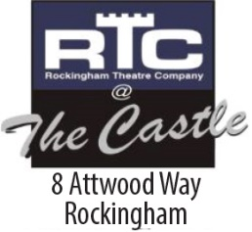
ROCKINGHAM ENTERTAINERS INCORPORATED –

trading as

ROCKINGHAM THEATRE COMPANY

Application for Membership

Ordinary Membership

Open to Adults who are, or will be, active participants in the Theatre.

Junior Membership (under 18)

Affiliate Membership

Open to anyone who wishes to support the theatre without being an active participant.

Show Membership

Open to cast/crew members participating in the current production only.

Mr/Mrs/Ms/Miss Please Print

FIRST NAME ……………………………………………………………………....…………..

SURNAME …………………………………………………………………………....………..

ADDRESS ……………………………………………………………………………....………

………………………………………………....………POSTCODE ……… …….

Phone …………………………………..Email Address ………..…………………………….

BIRTH DATE………/………/……… SIGNATURE....................................................... ........
*All Photographs taken on behalf of Rockingham Theatre Company remain the property of Rockingham Theatre Company and may not be used for publicity purposes.

Name of RTC Member Nominating:

……………………………….………………………………………………………….

Please complete and email to rtcinfoteam@gmail.com

Your application will be assessed within 5 working days and you will be notified of the outcome by email.

