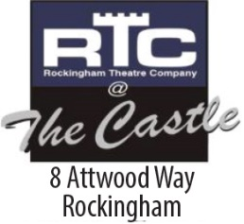
ROCKINGHAM ENTERTAINERS INCORPORATED –

trading as

ROCKINGHAM THEATRE COMPANY

Application for Membership

Ordinary Membership ($45)

Open to Adults who are, or will be, active participants in the Theatre.

Junior Membership (under 18) ($10)

Affiliate Membership ($10)

Open to anyone who wishes to support the theatre without being an active participant.

Show Membership ($15)

Open to cast/crew members participating in the current production only.

Mr/Mrs/Ms/Miss Please Print

FIRST NAME ……………………………………………………………………....…………..

SURNAME …………………………………………………………………………....………..

ADDRESS ……………………………………………………………………………....………

………………………………………………....………POSTCODE ……… …….

Phone …………………………………..

Email Address ………..…………………………….

BIRTH DATE………/………/……… SIGNATURE....................................................... ........
*All Photographs taken on behalf of Rockingham Theatre Company remain the property of Rockingham Theatre Company and may not be used for publicity purposes.

Name of RTC Member Nominating:

……………………………….………………………………………………………….

Please complete and email to rtcinfoteam@gmail.com

Your application will be assessed within 5 working days and you will be notified of the outcome by email.

